  Erin Savage  Principal | Lakewood High School  1400 54th Ave South  St. Petersburg, FL 33705  Phone: 727-893-2916  FAX: 727-893-1387 | Assistant Principals:  Tequena Akintonde  Cristina Calderon  Laura Mudd  Joseph Serra

The Mission of Lakewood High School is to create and nurture a foundation for learning and academic success where students take pride in their accomplishments and develop character traits, which have a positive impact on their education experience.

The Mission of the Lakewood High School AVID program is to close the Opportunity Gap by preparing all students for College and Career readiness with the goal of securing their success in a Global Society.

November 27, 2022
Greetings Spartans,
I hope you each had an enjoyable and restful Thanksgiving Break and were able to spend it with friends and family. Monday November 28th we will return to school ready to conduct the business of educating our Scholars. Monday will be a “B” Day (Periods 2,4,6,8).
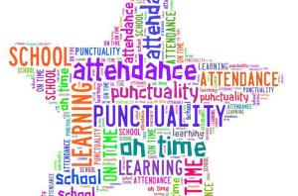
Punctuality and Attendance are crucial to your child’s success in school. Please make sure they get a good night’s sleep and are on time each day to school. Student hours are from 7:10 A.M. – 1:55 P.M.

KUDOS
Congratulations to the Varsity Football Team for defeating Tampa Catholic (11/18) and Calvary Christian (11/25) moving us into the State Semi-Finals. We will play Miami Central on December 2nd in Miami.

Congratulations to the Girls’ Basketball Team for defeating Bradwell Institute 46-40 and Jacksonville Ribault 44-42 at the Inside Exposure Thanksgiving Invitational in Jacksonville.

Progress Monitoring 2
We will begin our 2nd round of ELA/Reading Progress Monitoring on December 5th and 6th. Your student’s attendance is crucial during this testing to ensure that they are meeting their goals academically. Please look carefully at the schedule below and make sure your student is in attendance on the day of testing.

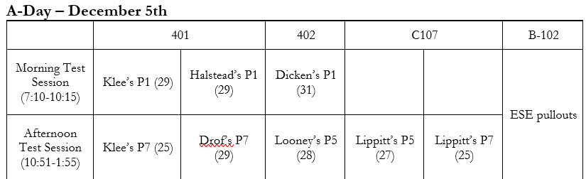

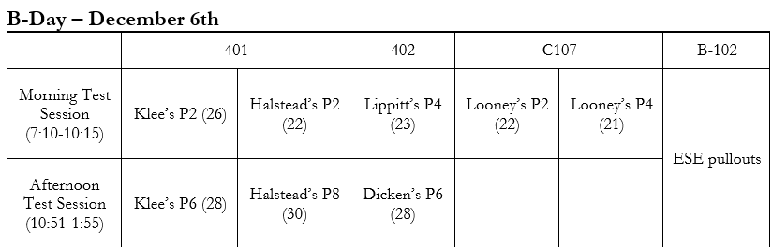

Semester 1 Exams
Please mark your calendars for the Semester 1 Exam Schedule. Students will be receiving information about Exam Exemptions soon via the morning and afternoon announcements.

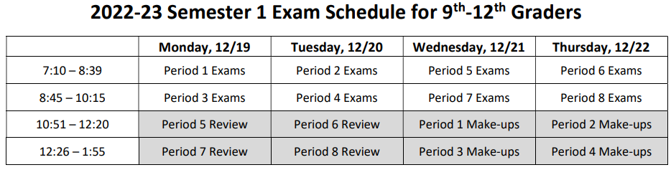

Weekly Calendar 11/28 – 12/3
Monday 11/28  B-Day | Soccer vs. Fivay
Tuesday 11/29  A-Day | Boys Basketball vs. Northeast  Girls Basketball @ Tampa Catholic  Soccer vs. Pinellas Park
Wednesday 11/30  B-Day | Boys Basketball vs. Parrish  Girls Basketball @ Hollins
Thursday 12/1  A-Day | Soccer @ Osceola
Friday 12/2  B-Day | Physics Day (Busch Gardens)  Boys Basketball vs. Seminole  Girls Basketball @ Cardinal Mooney  Varsity Football @ Miami Central  Wrestling @ Osceola
Saturday 12/3 | Wrestling @ Osceola  Enjoy Your Weekend!

If you have any questions, please feel free to contact the school at 727.893.2916.

